Lead Scoring Case Study Subjective Questions

- Which are the top three variables in your model which contribute most towards the probability of a lead getting converted?

Ans: Based on the analysis made from the final model which consists of 10 variables, the top 3 variables which contribute the most towards the probability of a lead getting converted are:
  - Lead Origin_Lead Add Form (From Lead Origin variable)
– having a coefficient which equal to 3.3372
  - Current_Occupation_Working Professional (From Current_Occupation Variable)
– having a coefficient which equal to 2.7915
  - Lead Source_Welingak Website (From Lead Source Variable)
– having a coefficient equal to 2.6610

- What are the top 3 categorical/dummy variables in the model which should be focused the most on in order to increase the probability of lead conversion?

Ans: The top three categorical/dummy variables in the model which are to be focused the
Most, in order to increase the probability of lead conversion rate are as follows:

  - Lead Origin_Lead Add Form – having a coefficient equal to 3.3372
  - Current_Occupation_Working Professional – having a coefficient equal to 2.7915
  - Lead Source_Welingak Website – having a coefficient equal to 2.6610

- X Education has a period of 2 months every year during which they hire some interns. The sales team, in particular, has around 10 interns allotted to them. So during this phase, they wish to make the lead conversion more aggressive. So they want almost all of the potential leads (i.e. the customers who have been predicted as 1 by the model) to be converted and hence, want to make phone calls to as much of such people as possible. Suggest a good strategy they should employ at this stage.

Ans: The optimal cutoff of final model is 0.3 as seen in picture below
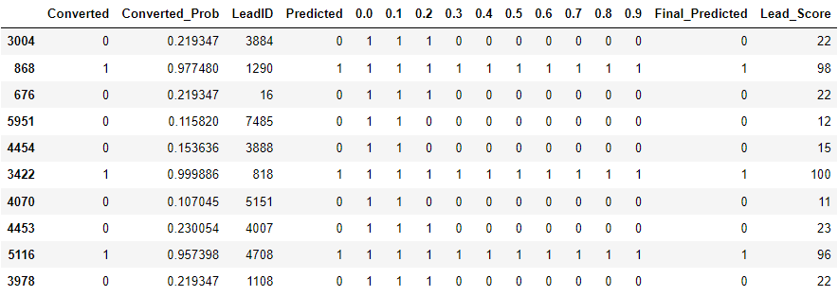

- Customers having a lead score of (30 or more)are more likely to join, so sales team has to be actively looking after these leads, and can adopt the strategy of connecting with all the leads so that we don’t miss any potential customer and educate them about the product,and maintain a constant communication.
- Once all the Customers having a lead_score of 30 or more have been catered, then the sales team should also consider and target customers with lead_score of 20 and above as there is a possibility of these customers to convert too

- Similarly, at times, the company reaches its target for a quarter before the deadline. During this time, the company wants the sales team to focus on some new work as well. So during this time, the company’s aim is to not make phone calls unless it’s extremely necessary, i.e. they want to minimize the rate of useless phone calls. Suggest a strategy they should employ at this stage.

Ans: One strategy to minimize the rate of useless call is to pick those customers having a lead score of 60 or above, since they are most likely to join the course, regular follow up would increase the chances of conversion .
If a customer is having a lead score lower than 60 or 70 but have a combination
of attributes which are, multiple visits to website, spending more than 10
minutes of their time on the website surfing for information regarding the course,
customer is a working professional or has Lead Source as ‘Welingak Website’
and has Lead Origin as ‘Lead Add Form’ or visited the site due to recommendation
provided by fellow students then those customers are most likely to convert and should
be our potential target.

